ABIRAMI K

230701008 CSE-A

EXP NO: 9 BANKERS DEADLOCK AVOIDANCE ALGORITHMS

PROGRAM

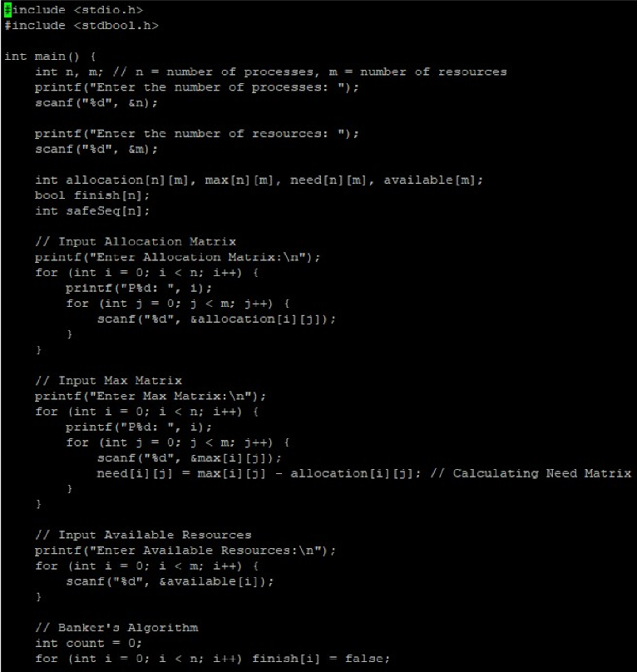

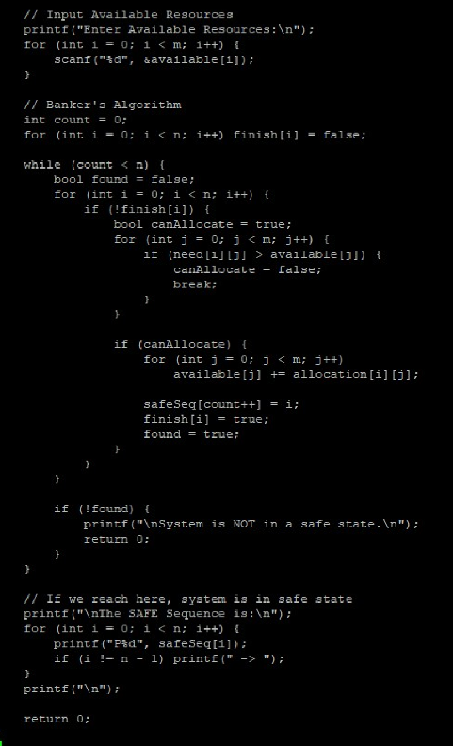

OUTPUT

